**Xtern 2022**

Using Google Maps API to plan out a day in Indianapolis

Ojashwi Uprety

**Introduction**

The goal of this project was to leverage Google Maps API to get location data and derive insights. As this is an assessment for Xtern, I figured planning a day around meeting the people at Techpoint would be a fun way to tackle this challenge.

The following report details the plans I made and my learnings about Indy in General. I am using Python and the Google Maps API supported by Google to collect and manipulate data. I am using an open source library called googlemaps to use Google Maps Platform Web Services in Python, and gmaps to visualize the data

**Where is TechPoint HQ?**

Just like how we use google search using keywords, I used googlemaps library to find the exact location of the TechPoint office. After a few attemps, I was able to pinpoint the coordinates.

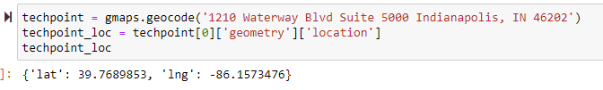

I then centered maps to the office location, and added a marker to mark the location so I can get added context about how the city looks like:

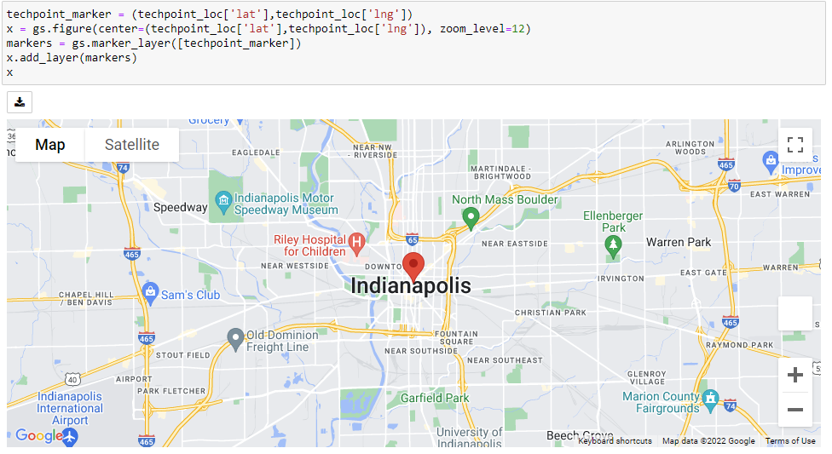

**Accommodation**

Since I would be coming from out of state, I needed to make sure I have a place to stay. So, my next step was to find hotels to stay at. I don’t want to be staying too far from TechPoint so that my morning commute is short. I used the ‘places_nearby’ function to locate hotels close to TechPoint and restricted the radius to 2km.

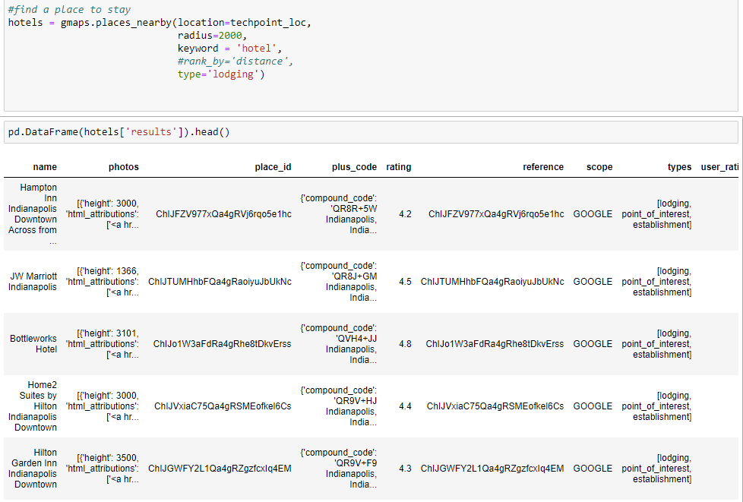

As someone who is particular about where I stay, I divided the hotels into 2 buckets based on their ratings: All hotels with ratings <= 4.4 and all hotels >4.4. In the figure below, we see that there are 3 hotels that meet my needs. After some research, I decided I would be staying in the Bottleworks Hotel. (All Yellow markers are hotels with rating <4.4).

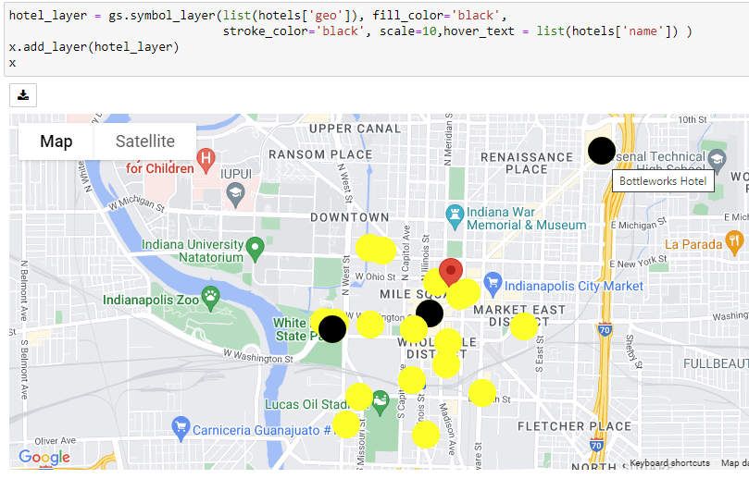

**Day Plan**

After finalizing my accommodation, I planned my day for when I get there. The first thing I wanted to do when I get to Indy is to visit TechPoint, meet the team and learn more about the amazing work that they do. I estimate my visit here to last up to 2 hours. Apart from that, I made a list of potential activities I want to do when in Indy:

* Visit Museums
* Visit some universities around
* Grab food

I used the API to pull data for potential locations and stored them in dataframes. I decided to keep a small radius of 5km from TechPoint as I didn’t want long commutes between places. The functions I am using tend to give data in chunks of 20 outputs; I figured that would be enough for universities and museums but decided to look at the next chuck of output (totaling to 40 outputs) for restaurants.

I then plotted the locations and added these plots to my initial visual with just TechPoint marked. This was the result:

Universities

Museums

Restaurants

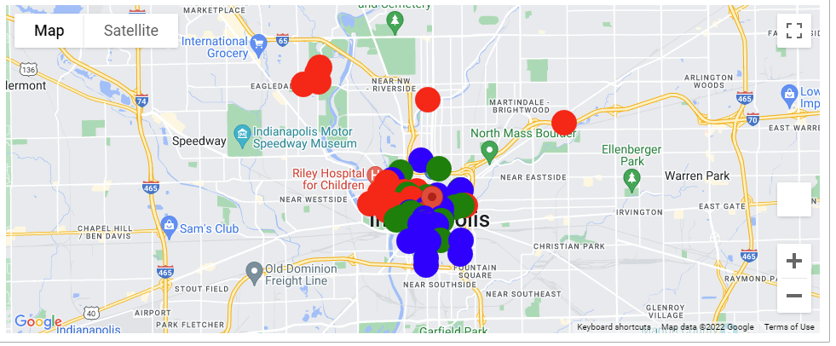

Looking at this graph, I noticed a cluster of schools for Indiana University directly west of TechPoint, and another one on Nort-west side.

Zooming a bit in the downtown area of Indy, I also noticed that there were a few museums close to the river, and a street called Massachusetts Avenue had a lot of restaurants.

After getting a better understanding about the area, this would be my plan for the day:

**9AM-11AM** – Visit TechPoint office

**11AM-12PM** – Grab brunch in Café Patachou

**12PM-3PM** – Visit a museum (or many) and take a walk by the White River

**3PM-6PM** – Visit Marian University and neighboring schools in North Indy.

**6PM-9PM**- Drive back to Massachusetts Avenue and walk around to try different restaurants and cuisines

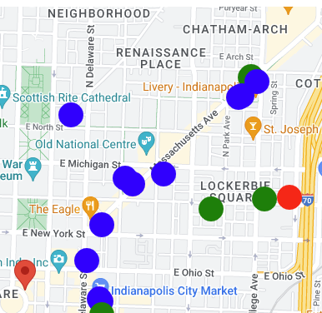

**9PM** – Return back to hotel and rest!